**Quiz 3: Tools of Geometry on the Coordinate Plane**

1. DG has endpoints *D*(−1, 8) and *G*(3, 4). What are the coordinates of its midpoint?
2. In radical form, what is the distance between points *L*(8, 9) and *Z*(−10, 0)?
3. 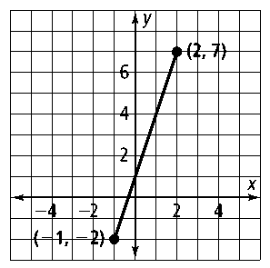Find the length and midpoint of the line segment to the right.

For questions 4 - 10 use the diagram on the right where *a//b & c//d.*

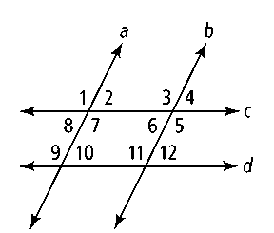

1. ∠2 and ∠10 are what kind of angles?
2. ∠3 and what angle are alternate interior angles?
3. ∠9 and ∠8 are what kind of angles?

7. *m*∠2 = 25˚ and *m*∠3 = _________ ? 8. *m*∠4 = 10˚ and *m*∠11 = _________ ?

9. *m*∠1 = 100˚ and *m*∠9 = _________ ? 10. *m*∠5 = 110 ˚ and *m*∠8 = __________ ?

**Use the given information to find the equation of the line. *You may use point-slope or slope-intercept form.***

1. slope –2 and passes through (0, 1)
2. passes through points (2, 1) and (–3, 5)

**Find the slope of  and *.* Then determine whether  and  are *parallel, perpendicular,* or *neither.* Explain.**

13**.** *L*(–2, –4), *M*(8, 6), *Q*(6, –4), *R*(–2, 4) 14**.** *L*(10, 7), *M*(4, –2), *Q*(2, 6), *R*(–8, –1)

**Determine whether the following pairs of lines are *parallel, perpendicular,* or *neither.***

15.  16.*y* = 3*x* − 2

3*x* + *y* = 2 −3*x* + *y* = 5

17. What is the equation of the line parallel to *y* = −6*x* + 2 that contains the point (1, 2)?

18. contains points (2, 1) and (−1, −8). What is the equation of the line perpendicular to ** that contains point (0, 2)?